# Serial command API

Connect your computer to the Arduino using a USB cable and make sure that you have selected the right COM port from the “Tools/Serial Port” menu. Click on the serial monitor button. Make sure that the baud rate is set to 115200 (number in the bottom right corner).

Now you can type any of the following commands into the text box at the top of the window and click the “Send” button (or press “Enter”). Note that any settings you change are stored in EEPROM and will persist even after the Arduino has been powered down/reset.

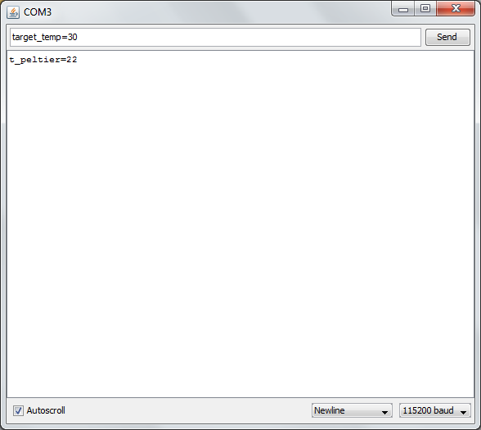

## Set the target temperature

**Command:**

*target_temp=x*

x is an integer representing the target temperature in degrees Celsius.

**Returns:**

*target_temp=x*

## Get the target temperature

**Command:**

*target_temp?*

**Returns:**

*target_temp=x*

## Set the ramp speed

**Command:**

*ramp_speed=x*

x is an integer in the range 0-255 which represents the ramp speed (255 is the maximum speed).

**Returns:**

*ramp_speed=x*

## Get the ramp speed

**Command:**

*ramp_speed?*

**Returns:**

*ramp_speed=x*

## Get the temperature of the thermocouple attached to the peltier

**Command:**

*t_peltier?*

**Returns:**

t_peltier=x